**SQl Server Project test and documentation**

**Team Members:**

**Boles Gamil**

**Mario Hemaya**

**Mina Girges**

**Team leader report about team members & Tasks:**

**Mina + Mario + Boles ----🡪 ERD**

**Mina + Mario + Boles --🡪 Mapping + test Normalization**

**All tasks for project created by zoom meeting**

**We upload mapping and query script for database in other files**

**ERD screenshot:**

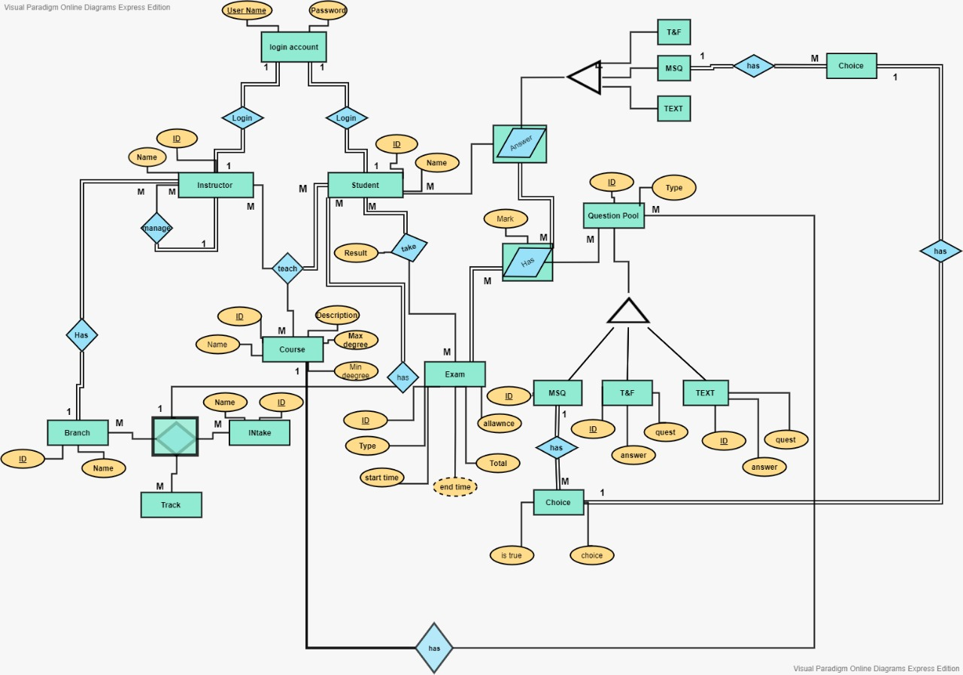

**Test Sheet (all objects, or you can make a table for each type)**

|  |  |  |  |  |  |  |
| --- | --- | --- | --- | --- | --- | --- |
| Developed By | Comment | Test Result | Test Query (Execute) | Parameters List | Description | Object  type/ Name |
| Mina |  |  | select *from GetManager; |  | GetManager | **view** |
| boles |  |  | select *from GetCourse |  | GetCourse | **View** |
| Mario |  |  | select * from GetQuestionA |  | GetQuestionA | **View** |
| Boles |  |  | select * from GetQuestionT |  | GetQuestionT | **View** |
| Mario |  |  | select * from GetQuestionC |  | GetQuestionC | **View** |
| Mina |  |  | exec getstudentcoures @coursename='HTML5'; | @coursename nvarchar(30) | select Course Student | **procedure** |
| Mario |  |  | exec checklogin @username='marioo'; | @username nvarchar(30) | Check user Student or Instructor | **procedure** |
| Boles |  |  | exec AddQuestion @username='ahmed', @ID=1 ,@question='Which of the following is correct about dynamic Type in C#?'; | @username nvarchar(30),@ID int,@question nvarchar(Max) | Check Instructor can add mcq question and add qusetion to his course | **procedure** |
| Mina |  |  | exec Addmcq @username='Ahmedd', @ID=1 ,@questionid=4, @choice='ToString',@true='T';  exec Addmcq @username='Ahmedd', @ID=1 ,@questionid=4, @choice='ToSingle',@true='F';  exec Addmcq @username='Ahmedd', @ID=1 ,@questionid=4, @choice='ToSbyte',@true='F';  exec Addmcq @username='minaaa', @ID=1 ,@questionid=4, @choice='ToInt64',@true='F'; | @username nvarchar(30),@ID int,@questionid int,@choice nvarchar(Max),@true char(1) | Check Instructor can add mcq choices and add choices to question | **procedure** |
| boles |  |  | exec AddQuestionTF @username='saraaa', @ID=1 ,@question='XHTML is case insensitive and HTML is case sensitive.', @answer='F'; | @username nvarchar(30),@ID int,@question nvarchar(Max),@answer char(1) | Check Instructor can add True&False questions | **procedure** |
| Boles |  |  | exec AddQuestionText @username='Saraaa', @ID=3 ,@question='How To Update yes To no And Viceversa In A Query?',  @answer='Update tablename set ColumnName1 '; | @username nvarchar(30),@ID int,@question nvarchar(Max),@answer nvarchar(Max) | Check Instructor can add Text questions | **procedure** |
| boles |  |  | exec AddBranch @username='ali' ,@namebranch='Giza'; | @username nvarchar(30),@namebranch nvarchar(50) | Check Admin Instructor To add A branch | **procedure** |
| Mina |  |  | exec AddIntake @username='Ahmedd' ,@nameintake='Intake 4'; | @username nvarchar(30),@nameintake nvarchar(30) | Check Admin Instructor To add A Intake | **procedure** |
| mina |  |  | exec AddTrack @username='Ahmedd' ,@nametrack='Laravel'; | @username nvarchar(30),@nametrack nvarchar(30) | Check Admin Instructor To add A Track | **procedure** |
| mina |  |  | exec UpdateTrack @username='Ahmedd' ,@nametrack='Laravel Program' ,@id=4; | @username nvarchar(30),@nametrack nvarchar(30),@id int | Check Admin Instructor To Update A Track | **procedure** |
| mario |  |  | exec UpdateIntake @username='Ahmedd' ,@nameintake='Intake Four' ,@id=4; | @username nvarchar(30),@nameintake nvarchar(30),@id int | Check Admin Instructor To Update A Intake | **procedure** |
| mario |  |  | exec UpdateBranch @username='Ahmedd' ,@namebranch='Brach Giza' ,@id=5; | @username nvarchar(30),@namebranch nvarchar(30),@id int | Check Admin Instructor To Update A Branch | **procedure** |
| mario |  |  | exec DeleteBranch @username='Ahmedd' ,@namebranch='Brach Giza'; | @username nvarchar(30),@namebranch nvarchar(30) | Check Admin Instructor To Delete A Branch | **procedure** |
| mina |  |  | exec DeleteTrack @username='Ahmedd' ,@nametrack='Laravel Program'; | @username nvarchar(30),@nametrack nvarchar(30) | Check Admin Instructor To Delete A Track | **procedure** |
| mina |  |  | exec DeleteIntake @username='Ahmedd' ,@nameintake='Intake Fours'; | @username nvarchar(30),@nameintake nvarchar(30) | Check Admin Instructor To Delete A Intake | **procedure** |
| boles |  |  | exec AddStudent @username='Ahmedd' ,@namestudent='tony Emad', @branchname ='Branch Assuit', @trackname ='Track .Net',@intakename='Intake 1' ,@usernamestd ='tonyyy',@passwordStd='22';  exec AddStudent @username='Ahmedd' ,@namestudent='ahmed Emad', @branchname ='Branch Assuit', @trackname ='Track .Net',@intakename='Intake 1' ,@usernamestd ='ahmwdd',@passwordStd='22'; | @username nvarchar(30),@namestudent nvarchar(50),@branchname nvarchar(50), @trackname nvarchar(50),@intakename nvarchar(50),@usernamestd nvarchar(30),@passwordStd nvarchar(30) | Check Admin Instructor To add A student | **procedure** |
| boles |  |  | exec DeleteStudent @username='Ahmedd' ,@namestudent='Ahmed Mohamed'; | @username nvarchar(30),@namestudent nvarchar(50) | Delete Student by Manger Instructor | **procedure** |
| mario |  |  | exec AddCourse @username='Ahmedd' ,@namecourse='Photoshop',@disc=null ,@maxdegree=100,@mindegree=60; | @username nvarchar(30),@namecourse nvarchar(50),@disc nvarchar(50),@maxdegree int,@mindegree int | Add Course by Manger Instructor | **procedure** |
| mario |  |  | exec generaterandommoques @numberofques=2 , @username='Ahmedd',@coursename='C#'; | @numberofques int, @username nvarchar(30),@coursename nvarchar(30) | Choose random Question true and false | **procedure** |
| mina |  |  | exec generatequestiontext @numberofques=2 , @username='Ahmedd',@coursename='C#'; | @numberofques int, @username nvarchar(30),@coursename nvarchar(30) | Choose random Question text ques | **procedure** |
| mina |  |  | exec generatequestionmcq @numberofques=2 , @username='Ahmedd',@coursename='C#'; | @numberofques int, @username nvarchar(30),@coursename nvarchar(30) | Choose random Question mcq question | **procedure** |
| mario |  |  | create Index Studentindex on Student (Name) |  |  | **index** |
| mario |  |  | create Index Courseindex on Course (Name) |  |  | **index** |
| mario |  |  | create Index Instructorindex on Instructor (Name) |  |  | **index** |
| mina |  |  | alter schema STU  transfer [dbo].[Student] |  |  | **schema** |
| boles |  |  | alter schema QEX  transfer [dbo].[TextQuestions] |  |  | **schema** |